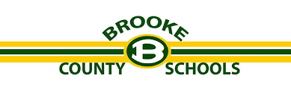
Summer Math Challenge
Parents,
In working with teachers throughout the school year, we have heard a continuous voice of students needing to be more fluent with their math facts. Therefore, we are challenging students to work on their math facts over the summer. When we return in August, students will be assessed on their math facts. There will be a competition between the north and south schools and a reward (i.e. ice cream social) for the school that is fluent in the most facts. As well, we would like to reward students who are fluent in ALL of their facts individually. The individual reward will be determined based off of how many students are successful.
We are asking all outgoing 2nd graders to work on their addition and subtraction facts for 3rd grade next year and all outgoing 3rd graders to work on their multiplication facts for 4th grade next year. To help at home we have included some resources. On the back of this page are some websites and apps that you can download/use for your student to practice with. Attached are other ways you can practice as well. Lastly, all of this information will be on our county website (https://www.brooke.k12.wv.us/) under Summer & Remote Learning.
We look forward to you returning for the 2020-2021 school year with your math facts more fluent so that we can help your student advance further in their mathematical learning.
Have a great summer!

Deanna Marsh
Brooke County Math Coach

