Directions on How to Get Rosters into Excel
Step 1: Open Live Grades and run a “Blank Roll Sheet”
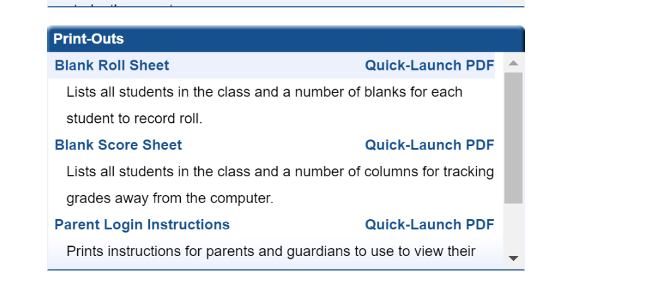
Step 2: Highlight and Copy the name and number column as shown.
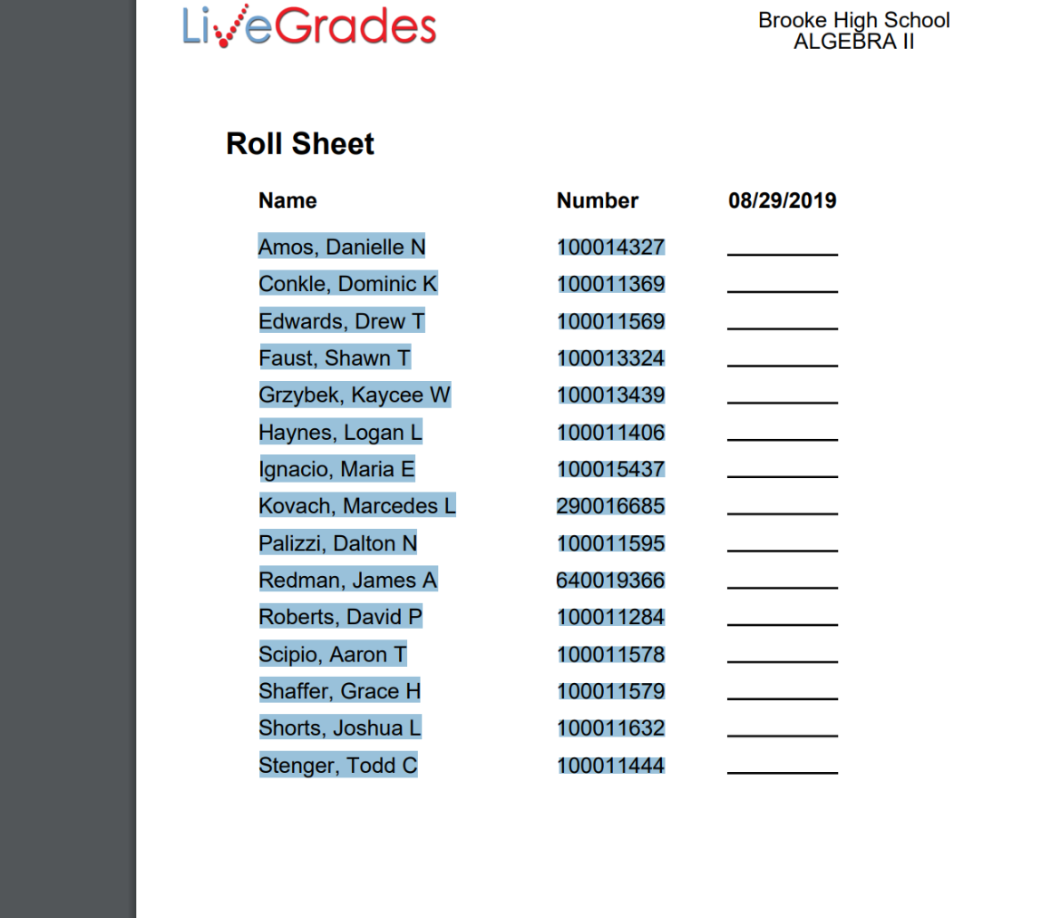

Step 3: Paste into a Word Document and separate the Last Name, First Name, Student ID by using tabs as shown below.
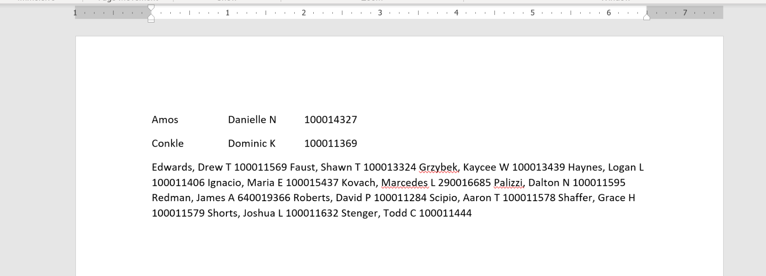

Step 4: Copy and Paste everything that you did in Word. Paste into an Excel file. Save the Excel with your Name and Period. For Example “Marsh – Pd1”
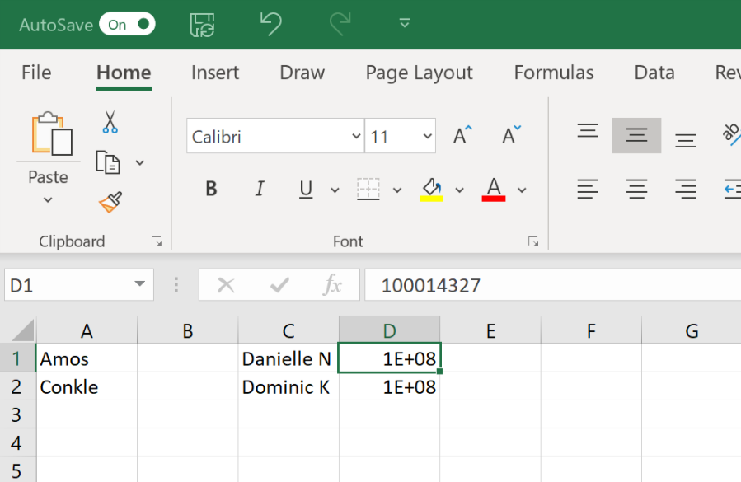
Do this for each of your classes and email me all of your files. Therefore, you should be emailing me six separate files for HS, 3 or 4 for MS, and only 1 for Intermediate.
For collab class situations, since classes aren’t merged in LiveGrades yet, you will have to run two roll sheets and copy both of them into ONE EXCEL FILE.

