Pearson Realize
Roll-Out Directions

SY 2019-2020

MOST IMPORTANT TO KNOW

LOGIN CHANGE INFORMATION
Login site: https://sso.rumba.pk12ls.com/sso/login?profile=eb&service=https://cat.easybridge.pk12ls.com/ca/dashboard.htm&additionalAttributes=Domains&k12int=true
Please note: On the login site, you should see that it is specific for Brooke County as seen below.
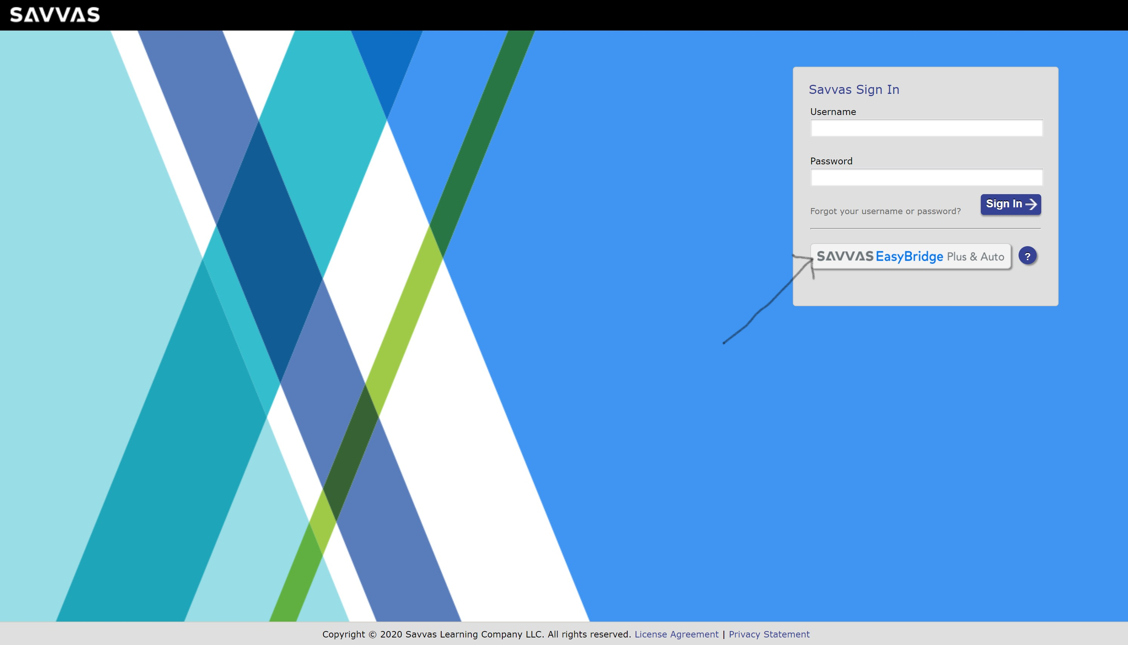
For the student login site, we recommend that you be sure students bookmark it. Also, you could make it available in your Google Classroom and your school webpage.

Teachers
Username: EmployeeID#@brook-wv
Password: password (all lowercase)
Students
Username: 9-digit WVEIS number
Password: BROOKE (all capitalized)

Teacher Set-up
You initially get sent to the EasyBridge website that shows you your classes. You will notice the current classes showing. Also your future classes are in a separate tab. There isn’t much you should have to do within this site. To get to your curriculum resources click on the realize link on the right.
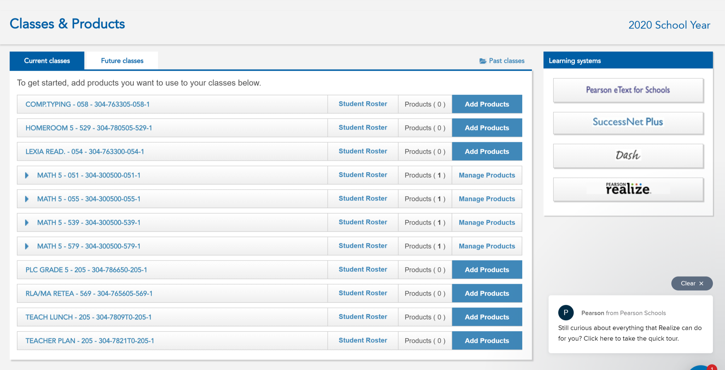

Once you get pushed to the realize site you should be prompted through some settings to set up for the first time.
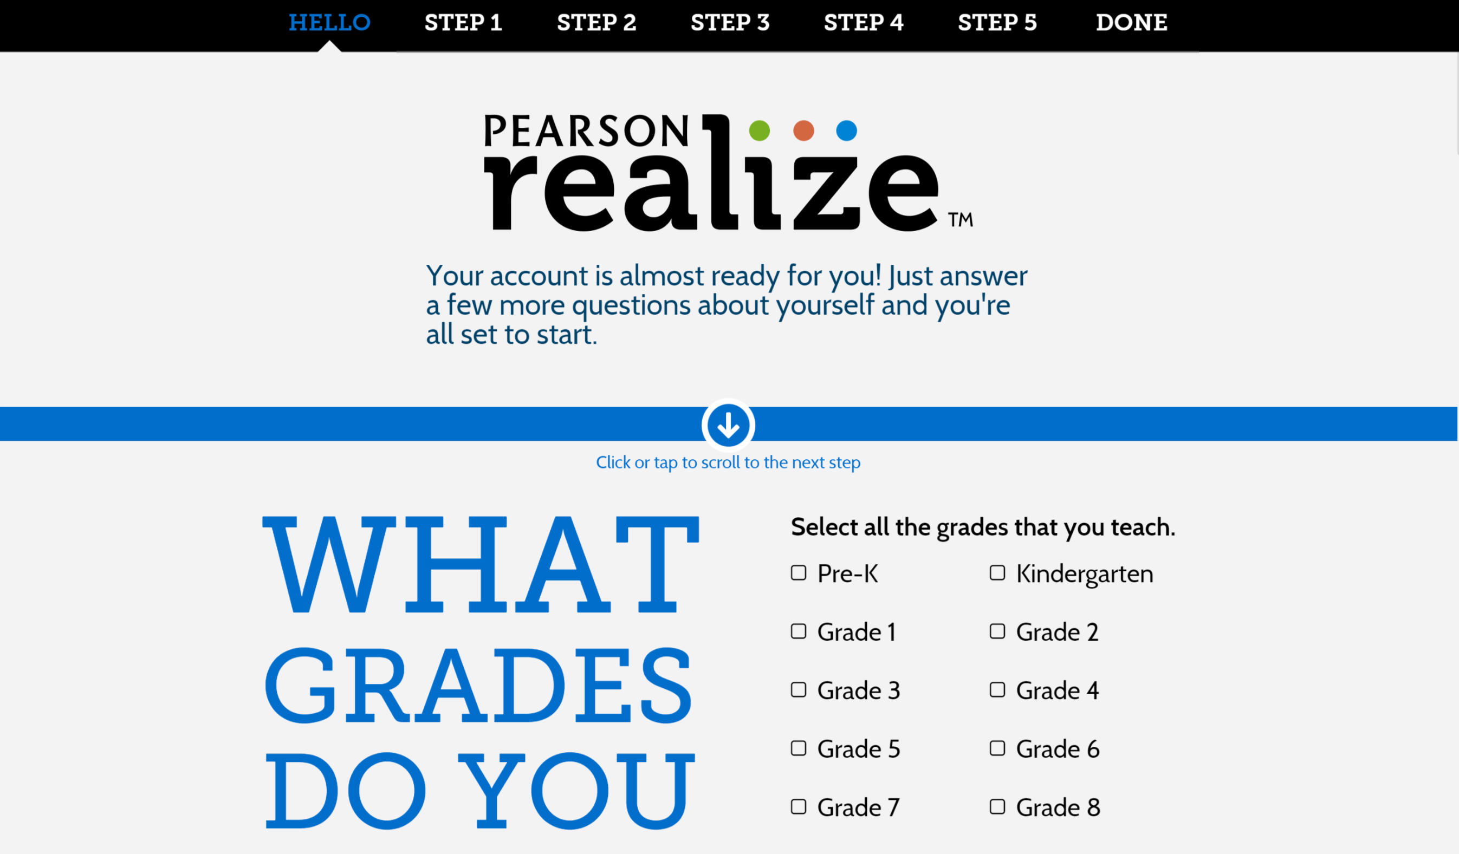
In the Step 2, be sure to select the appropriate Envision curriculum(s) highlighted below depending on what grade level(s) you teach.
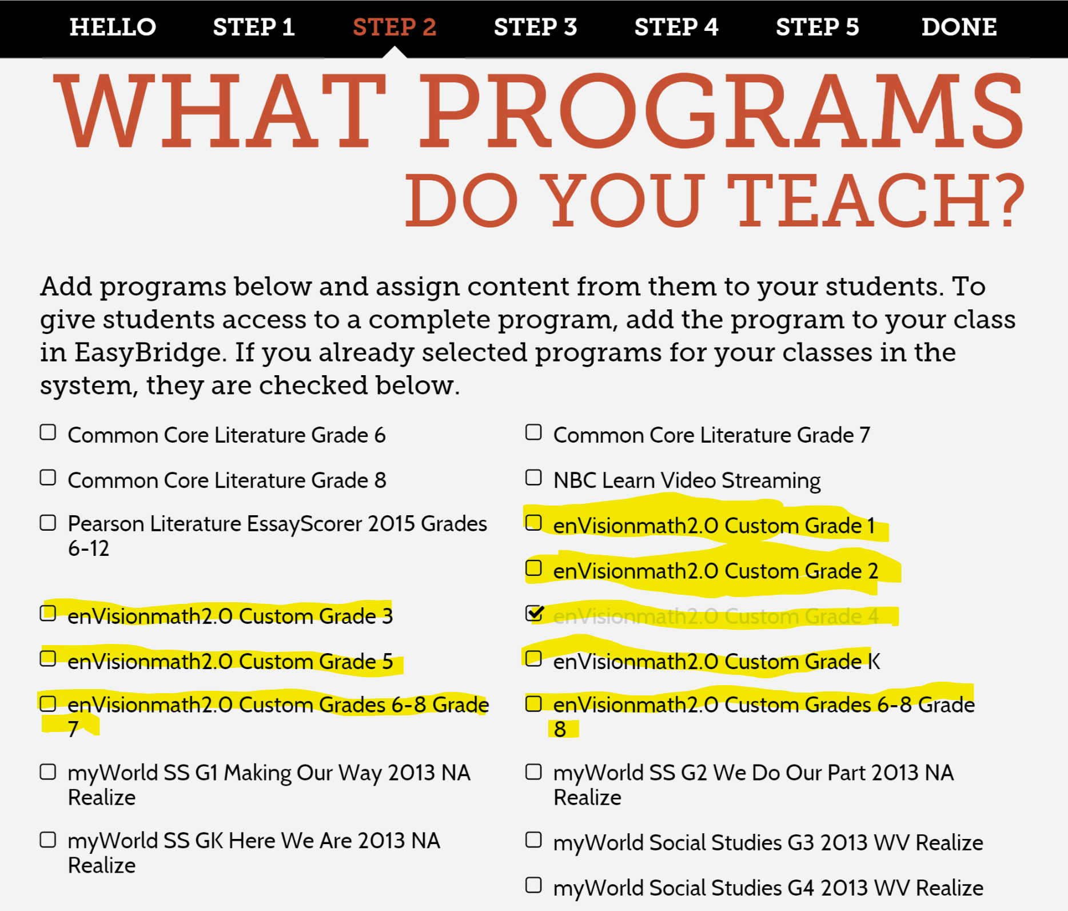

When you get into Realize this will be your home screen
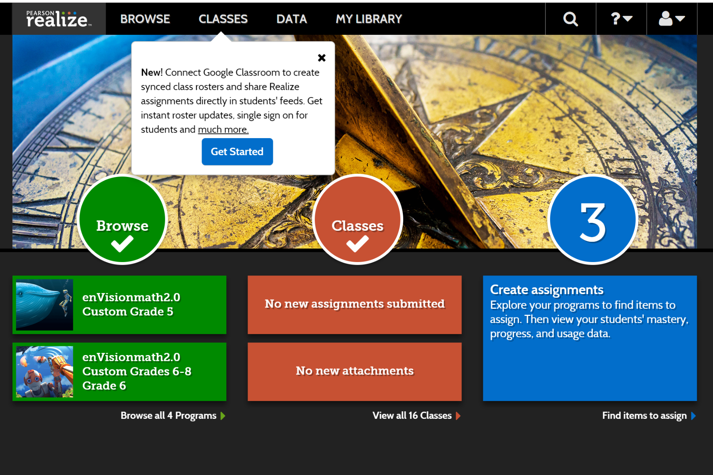
If you click on the classes tab at the top you will see all of your math courses. Please note that for each class you will actually see four classes. Because we use EasyBridge, the names match with what is in WVEIS. However, because initially there were four classes with the same name (one for each grading period), we had to make the class names longer in order to be able to distinguish the classes when assigning work to students. Therefore the -1 class is for the first grading period, -2 for the 2nd nine weeks and so on. You do not have the ability to change the names of these classes.
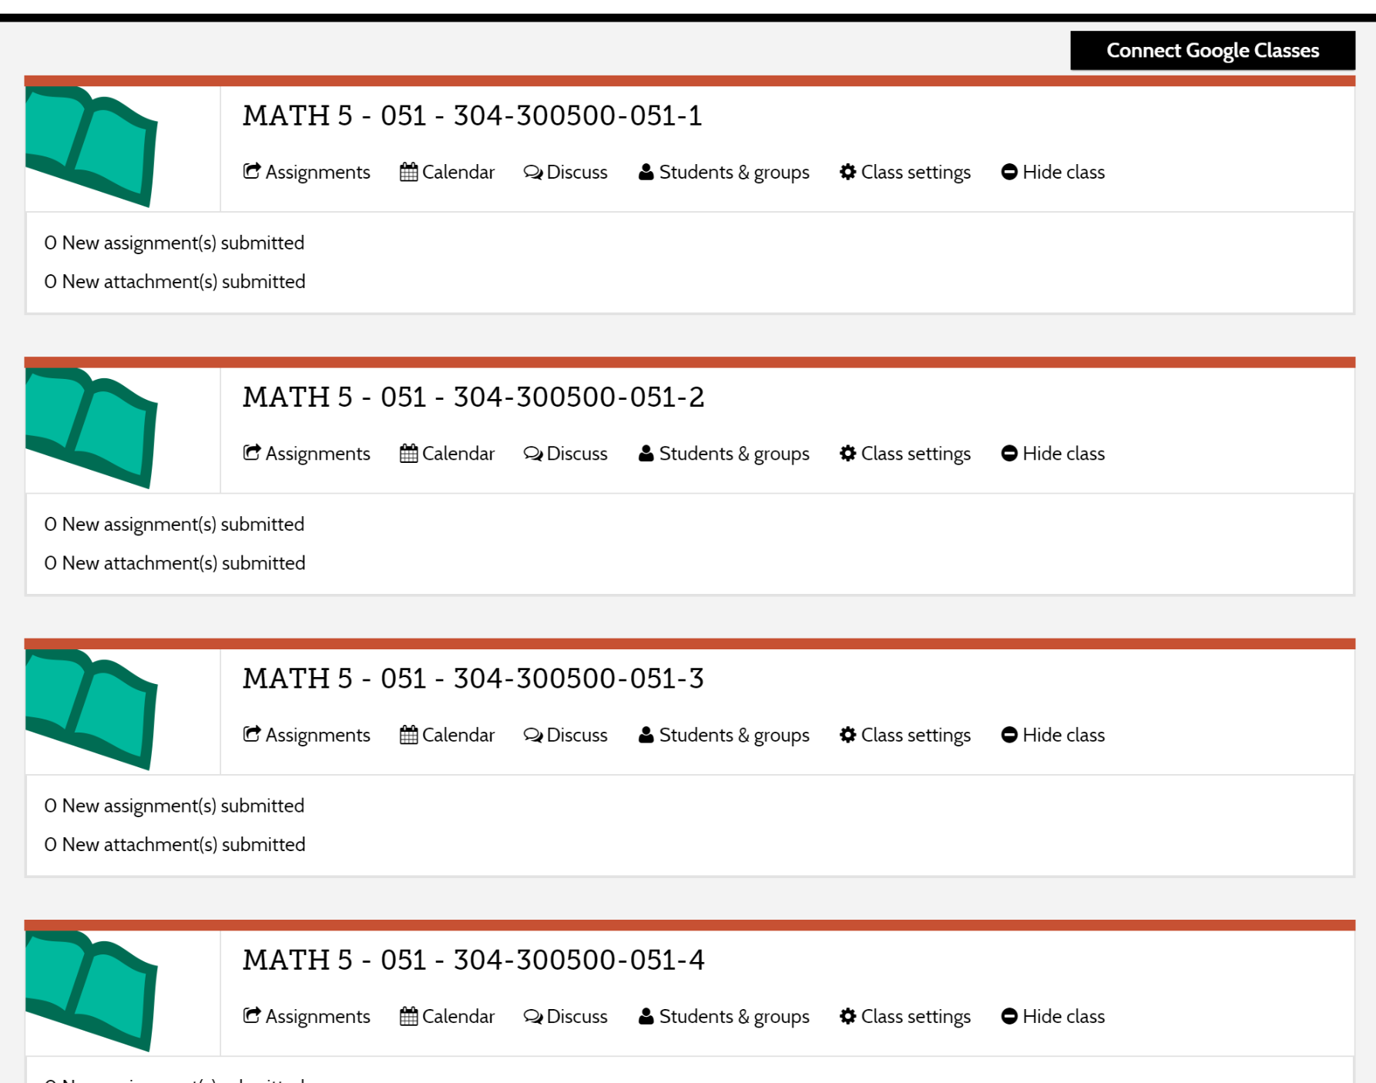
The rest of PearsonRealize should be just as it was before.
If you go to any of the topic/lessons and want to assign anything to students, just click on the ‘assign’ link under the resource/material.
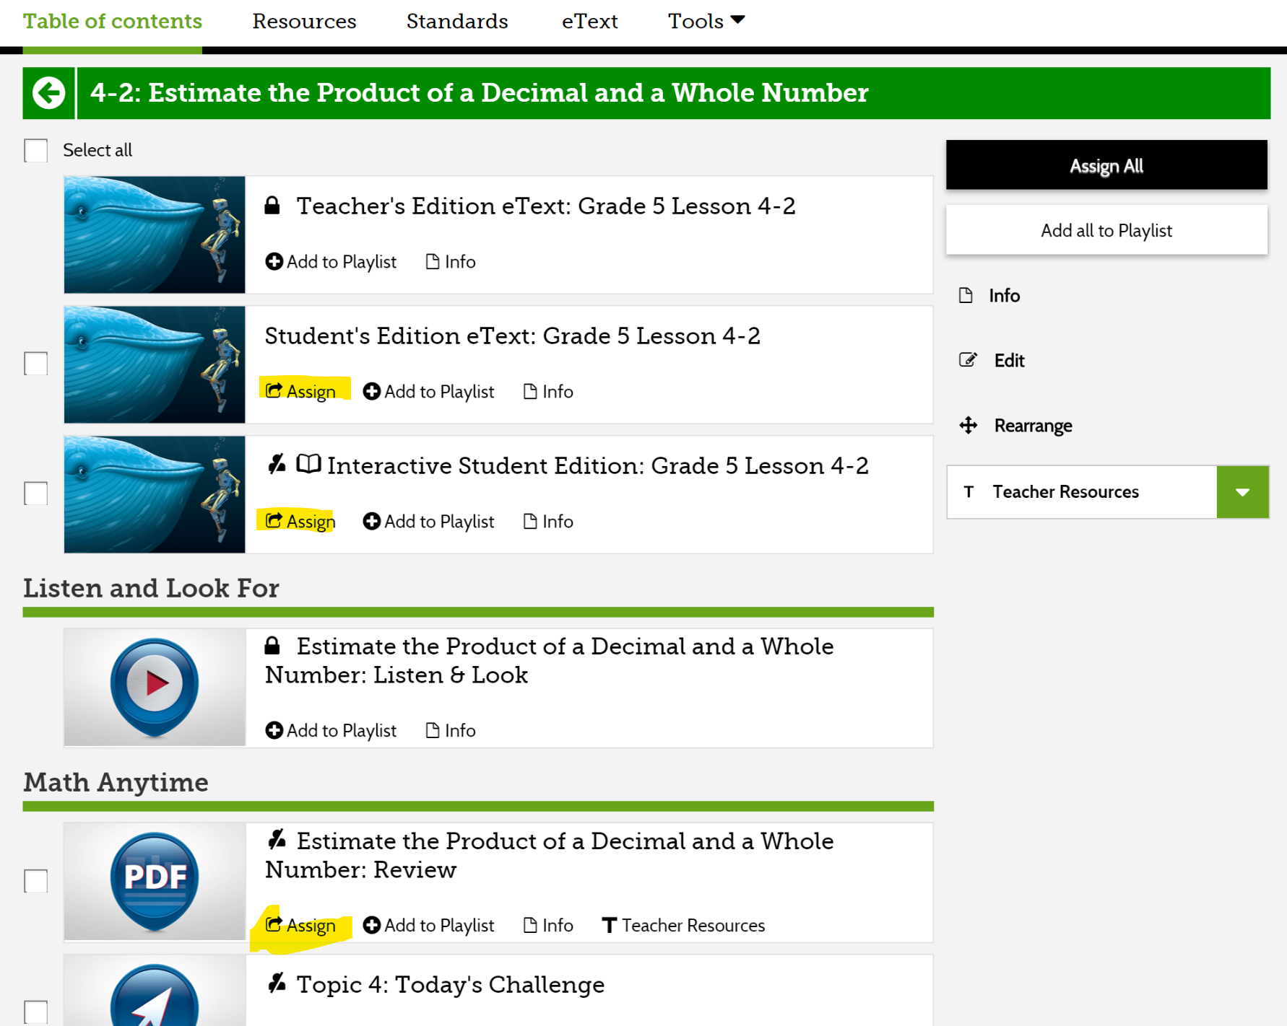
Start typing the name of the class for a drop-down menu of class names to show. Be sure you choose the correct class for the appropriate grading period, otherwise it will not show on the students’ side.
