Math Facts Pro
Student Directions

Go to www.mathfactspro.com

Click on Student Login

In the Student Login Box, fill out the following information
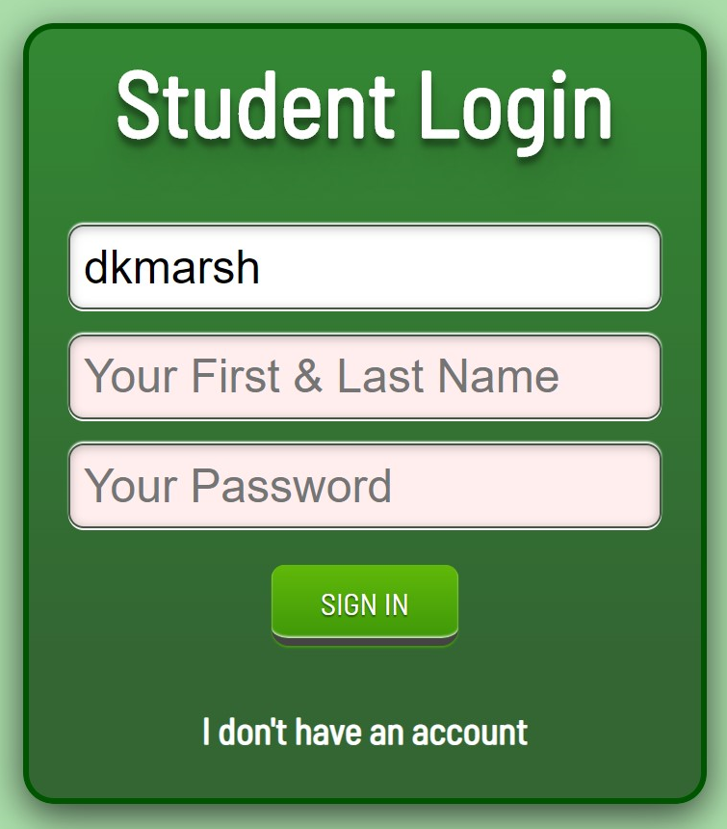

Once logged in, you will see a box like this that you can start typing or clicking in your answers.

